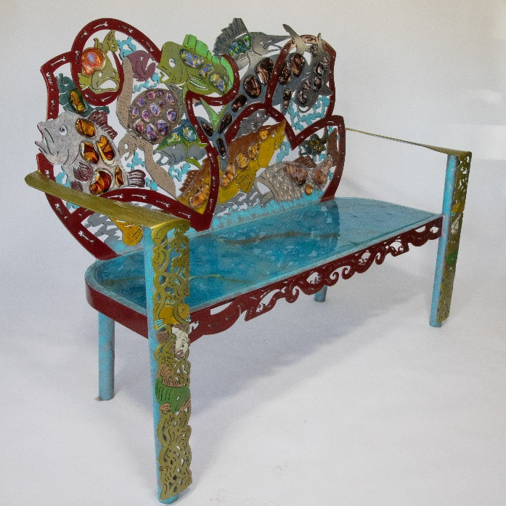

CALL TO ALL ARTISTS AT UC SAN DIEGO

Join artist, James Stone in creating an exciting new installation of public art for our campus! Stone has been commissioned by the Chancellor at UC San Diego to create several public art pieces for campus and is inviting students from all majors to collaborate on this unique effort. The project includes the design and fabrication of 10 permanently installed glass and metal art benches at Eighth College. Participants will have the opportunity to submit initial concept sketches that, if selected, will inform the final bench design. All design contributors are welcome to be a part of the fabrication process to whatever extent they are interested.

No prior art experience is required and participants do not need to be visual arts students! Interested parties should attend a presentation at the Craft Center (located in New Sixth College) on Wednesday, November 2 from 4-6 pm. Stone will give a presentation on the project and provide some background on his process and experience as a well-known and very experienced glass artist. Attendees may create concept sketches during this event in response to the presentation or may submit renderings/sketches digitally by emailing files to info@stoneandglass.com by November 9.

The call is open to all UC San Diego students. Preference will be given by the selection committee to designs that include some aspect of UC San Diego.

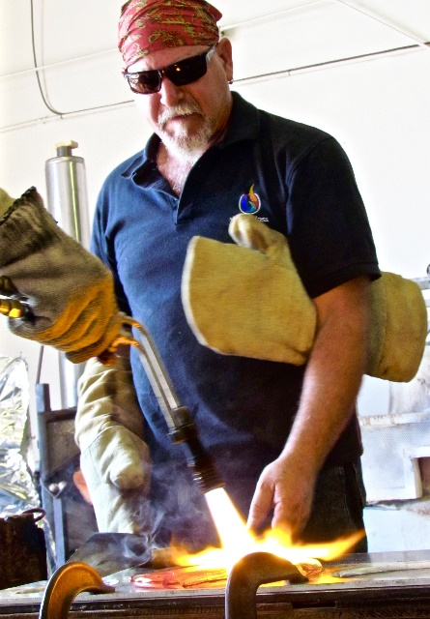

ARTIST BIO: James Stone describes himself as an ocean conservation mixed media sculpture artist, working full-time out of his environmentally conscious hot glass studio in Escondido, California. He is best known for his use of color, and his unique process of casting hot glass directly out of the furnace into sculpted metal to create stunning works of art. His one-of-a-kind technique forges metal and hot cast glass and includes painted accents. Each piece has a long creation cycle and requires a significant time investment and level of experience. Stone’s work is included in public and private collections worldwide.

